Identify the Controls & Variables Name __________________________ Hour ____
Smithers thinks that the special juice will increase the productivity of workers. He creates two groups of 50 workers each and assigns each group the same task (in this case, they’re supposed to staple a set of papers). Group A is given the special juice to drink while they work. Group B is not given the special juice. After an hour, Smithers counts how man stacks of papers each groups has made. Group A made 1,587 stacks, Group B made 2,113 stacks. | Identify the:  1. Control Group ______________________________  2. Independent Variable ________________________  3. Dependent Variable _________________________  4. What should Smithers’ conclusion be? ___________ _____________________________________________ _____________________________________________  5. How could this experiment be improved? ________ ____________________________________________ ____________________________________________
Homer notices that his shower is covered in a strange green slime. His friend Barney tells him that coconut juice will get rid of the green slime. Homer decides to check this out by spraying half of the shower with coconut juice. He sprays the other half of the shower with water. After 3 days of “treatment” there is no change in the appearance of the green slime on either side of the shower. | 6. What is the initial observation? _________________ _____________________________________________  Identify the:  7. Control Group ______________________________  8. Independent Variable ________________________  9. Dependent Variable _________________________  10. What should Homer’s conclusion be? ___________ _____________________________________________ _____________________________________________
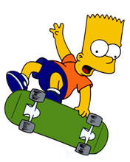  Bart believes that mice exposed to microwaves will become extra strong (maybe he’s been reading too much Radioactive Man). He decides to perform this experiment by placing 10 mice in a microwave for 10 seconds. He compared these 10 mice to another 10 mice that had not been exposed. His test consisted of a heavy block of wood that blocked the mouse food. He found that 8 out of 10 of the microwaved mice were able to push the block away. 7 out of 10 of the non-microwaved mice were able to do the same. | Identify the:  11. Control Group _____________________________  12. Independent Variable _______________________  13. Dependent Variable _________________________  14. What should Bart’s conclusion be? _____________ _____________________________________________ _____________________________________________  15. How could Bart’s experiment be improved? ______ ____________________________________________ ____________________________________________
Krusty was told that a certain itching powder was the newest best thing on the market, it even claims to cause 50% longer lasting itches. Interested in this product, he buys the itching powder and compares it to his usual product. One test subject (A) is sprinkled with the original itching powder, and another test subject (B) was sprinkled with the experimental itching powder. Subject A reported having itches for 30 minutes. Subject B reported to have itches for 45 minutes. | Identify the:  16. Control Group _____________________________  17. Independent Variable _______________________  18. Dependent Variable _________________________  19. Explain whether the data supports the advertisements claims about its product? __________ _____________________________________________ _____________________________________________
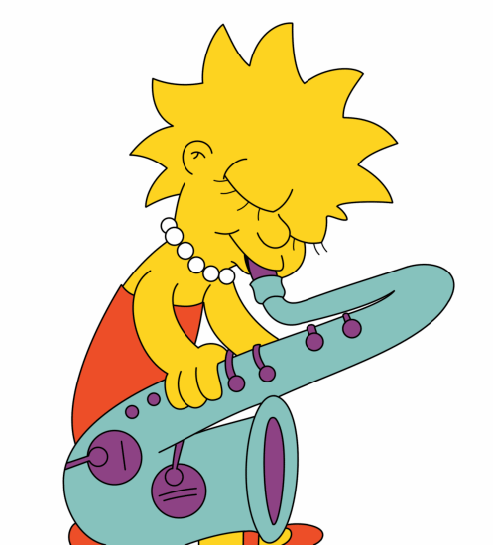  Lisa is working on a science project. Her task is to answer the question: “Does Rogooti (which is a commercial hair product) affect the speed of “hair growth”. Her family is willing to volunteer for the experiment. | 20. Describe how Lisa would perform this experiment. Identify the control group, and the independent and dependent variables in your description.

20. ________________________________________________________________________________________ ___________________________________________________________________________________________ ___________________________________________________________________________________________ ___________________________________________________________________________________________ ___________________________________________________________________________________________ ___________________________________________________________________________________________ ___________________________________________________________________________________________ ___________________________________________________________________________________________ ___________________________________________________________________________________________ ___________________________________________________________________________________________ ___________________________________________________________________________________________ ___________________________________________________________________________________________ ___________________________________________________________________________________________ ___________________________________________________________________________________________ ___________________________________________________________________________________________ ___________________________________________________________________________________________ ___________________________________________________________________________________________ ___________________________________________________________________________________________ ___________________________________________________________________________________________ ___________________________________________________________________________________________

