Name Date Class
CHAPTER 7
Section 3: Structures and Organelles
Study Guide

In your textbook, read about structures and organelles.
Label the diagram of a typical animal cell. Use these choices:

cytoplasm | endoplasmic reticulum | Golgi apparatus | microtubules
mitochondrion | nucleolus | nucleus
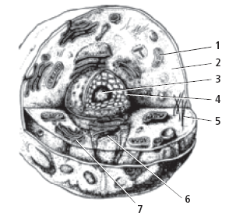
1.
2.
3.
4.
5.
6.
7.

If the statement is true, write true. If the statement is false,
replace the italicized word or phrase to make it true.
8. Microtubules are long, hollow protein cylinders that form a rigid skeleton for
the cell.

9. The Golgi apparatus contains most of the cell’s DNA.

10. The nucleolus is the structure that produces sugars.

11. The endoplasmic reticulum is a stack of membranes that packages proteins into
sacs called vesicles.

12. The cytoplasm is the semifluid internal environment of the cell.

Unit 2 CHAPTER 7 Cellular Structure and Function 53

