Name Date Class
CHAPTER 9
Section 2: Mitosis and Cytokinesis
Study Guide

In your textbook, read about the stages of mitosis.
For each statement below, write true or false.
1. The nuclear membrane disintegrates during prophase.
2. Microtubules move chromatids to the poles of the cell during anaphase.
3. Chromosomes reach the poles of the cell during metaphase.
4. The cell’s chromatin condenses into chromosomes during prophase.
5. The nuclear envelope re-forms during anaphase.
6. Chromosomes attach to spindle fibers and line up along the equator of
the cell during metaphase.
7. The nucleus reappears during prophase.
8. Centrioles migrate to the poles of the cell during telophase.
9. Chromatids are pulled apart during anaphase.
10. The first stage of mitosis is telophase.
11. The chromosomes decondense or unwind during telophase.
12. One of the shortest stages of mitosis is metaphase.
Label the diagram of the stages of mitosis using lines 13–16. Use these choices:

anaphase | metaphase | prophase | telophase

13.
14.
15.
16.

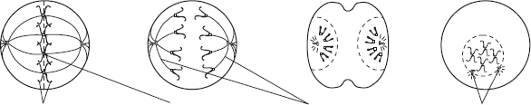

17.
18.
19.
20.
Label the diagrams above using lines 17–20. Use these choices:
centrioles | centromere | sister chromatids | spindle fibers
126 Cellular Reproduction CHAPTER 9 Unit 2
Study Guide, Section 2: Mitosis and Cytokinesis continued

In your textbook, read about cytokinesis.
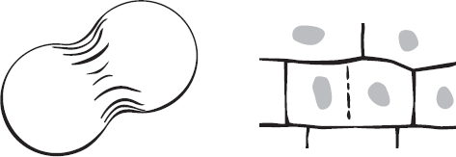

Animal cell | Plant cells
Refer to the diagrams above. Respond to each statement.
21. Discuss the role of microfilaments in cytokinesis.

22. Summarize cell division in prokaryotes.

Draw the formation of two genetically identical cells in plants in the space below. Include the
following labels: cell plate, identical daughter cells, new cell wall.
23.

Unit 2 CHAPTER 9 Cellular Reproduction 127

