Name Date Class
Study Guide

CHAPTER 3
Section 1: Community Ecology

In your textbook, read about limiting factors.
Complete the table by checking the correct column(s) for each limiting factor

Limiting Factor | Abiotic Factor | Biotic Factor
1. Temperature
2. Rainfall
3. Predator
4. Soil chemistry
5. Prey
6. Plant nutrients
7. Oxygen
8. Sunlight
9. Climate
10. Producers
In your textbook, read about ecological succession.
Use each of the terms below only once to complete the passage.
abiotic factors | climax community | ecological succession
ecosystems | fire | lava flow
pioneer species | primary succession | secondary succession

(11) are constantly changing. Both (12)
and biotic factors change in every ecosystem. One type of ecosystem change, called
(13) , results in one community replacing another over time.
This process might begin on bare rock, such as a(n) (14) . The process
begins when (15) begin living on the rock. This process is called
(16) . The mature community that eventually forms is called the
(17) . Sometimes that community is destroyed by a(n)
(18) . A new community will replace the destroyed one through the
process of (19) .

Unit 1 CHAPTER 3 Communities, Biomes, and Ecosystems 85
In your textbook, read about primary succession.
Number the pictures below in the order in which they occur, showing the changes that take
place during primary succession.
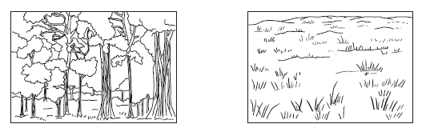

20. | 22.
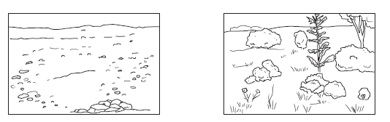

21. | 23.
In your textbook, read about secondary succession.
Respond to each statement.
24. Name the material that is present for secondary succession that is not present for
primary succession.

25. Cite two reasons why secondary succession is faster than primary succession.

26. Recall the name for the mature community that develops in secondary succession.

86 Communities, Biomes, and Ecosystems CHAPTER 3 Unit 1

