Name Date Class
Study Guide
CHAPTER 8
Section 3: Cellular Respiration

In your textbook, read about cellular respiration and glycolysis.
Use each of the terms below only once to complete the passage.

aerobic | anaerobic | ATP | cellular respiration | cytoplasm | energy
glucose | glycolysis | mitochondria | NADH | oxygen

Organisms obtain energy in a process called (1) . This process harvests
electrons from carbon compounds, such as (2) , and uses that energy to
make (3) . ATP is used to provide (4)
for cells to do work. In (5) , glucose is broken down into pyruvate.
Glycolysis is a(n) (6) process because it does not require oxygen. Glycolysis
takes place in the (7) . Two molecules of ATP and two molecules of
(8) are formed for every glucose molecule that is broken down.
(9) respiration takes place in the (10) .
It is aerobic because the process requires (11) .

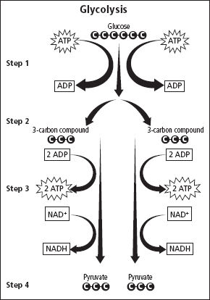
Refer to the diagram of glycolysis. Label the steps in the
description to match the diagram.
12. Step . Each three-carbon compound is
converted into a three-carbon pyruvate.
13. Step . A six-carbon compound is broken down
into two three-carbon compounds.
14. Step . Phosphate groups from two ATP
molecules are transferred to a glucose molecule.
15. Step . Two NADH molecules and four ATP
molecules are produced.
Respond to each question.
16. Interpret How many total ATP molecules
are produced from the glycolysis of one
six-carbon glucose?

17. Explain Why is there a net gain of only two ATP
molecules in the glycolysis of one six-carbon glucose?

Unit 2 CHAPTER 8 Cellular Energy 91
Study Guide, Section 3: Cellular Respiration continued

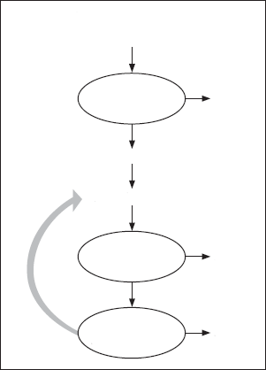
In your textbook, read about the Krebs cycle, electron
transport, and anaerobic respiration.
Cellular Respiration
Refer to the diagram of cellular respiration. Respond to
each question and statement.
Glucose
with oxygen
18. Recall What is the net yield of ATP produced by
each of the circled processes in the diagram?
Glycolysis
2 ATP
Glycolysis = ATP
Krebs cycle = ATP
with oxygen
Pyruvate
Electron transport chain = ATP
Acetyl-CoA
19. Find the total net yield of ATP from one
molecule of glucose.
Krebs cycle
2 ATP
20. Specify Based on the diagram and your
calculations, which process produces more
energy—the anaerobic pathway or the
aerobic pathway?
32 ATP
Electron
transport chain

For each statement below, write true or false.
21. The anaerobic pathway that follows glycolysis in the absence of oxygen
is fermentation.
22. The hydrogen necessary in the electron transport chain comes from the
splitting of carbon dioxide molecules.
23. Cellular respiration in eukaryotes is slightly more efficient than in prokaryotes.
24. The Krebs cycle is sometimes called the TCA cycle or the citric acid cycle.
25. Fermentation occurs in the mitochondria.
26. Skeletal muscle produces lactic acid when the body cannot supply
enough oxygen.
27. Alcohol fermentation is found in some bacteria and in humans.
28. The two pyruvate molecules formed during glycolysis result in two Krebs cycles.
29. Electron transport is the first step in the breakdown of glucose.

92 Cellular Energy CHAPTER 8 Unit 2

