Metamorphic Rocks
- This process is the transformation of one rock type into another caused by changes in __________________________________ and _________________________________ (stress).
- Contact Metamorphism – alteration of a rock, mainly by _______________________, that occurs near a heat source such as a magma chamber
- Regional Metamorphism - metamorphism across a broad area caused by the elevated temperatures and pressure of __________________________________________ or deep burial
Metamorphic Rock Textures
- Foliated – caused by differential stress, the crystals will recrystallize with preferred orientation, perpendicular the direction of the compressional force.
  - show ________________________________ due to pressure
- Nonfoliated – metamorphic rocks composed of only one mineral with _____________________ _______________________________

Nonfoliated vs. Foliated
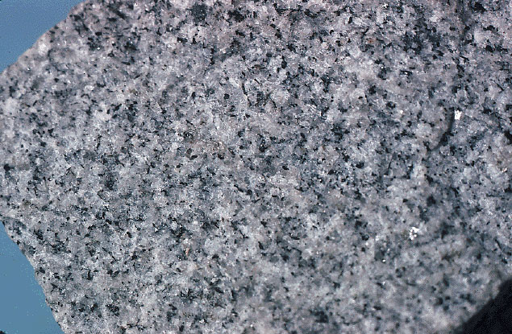
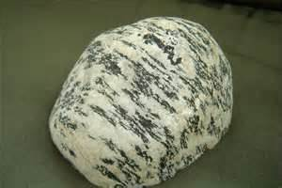

Classifying Metamorphic Rocks
