Sedimentary Rocks
- Sedimentary rocks are formed by the process of ___________________________________.
  - The weathering debris are constantly being swept away from bedrock and carried away by water, ice, and wind (aka. Erosion).
  - The debris is eventually _______________________________________ into lakes, river valleys, seas, and countless other places.
  - As the sediments accumulate, the materials near the bottom are ___________________ by the weight of the overlying layer. Over long periods of time, these sediments are cemented together by mineral matter deposited from water in the spaces between particles.
Sedimentary Rocks
- Lithification – refers the processes by which sediments are transformed into solid sedimentary rocks.
  - Compaction – ______________________________________
  - Cementation - minerals are carried in solution by water seeping through the pore spaces between particles. Over time, the cement precipitated onto the sediment grains, filling the _______________ spaces, _____________________________ the particles together.
    - Calcite, silica, and _________________________________ are the most common cements
Sedimentary Rocks
- Sedimentary rocks provide __________________________________ with evidence of Earth’s long history.
  - Past environments
    - Conglomerate – indicates high-energy environment, such as rushing ___________________, where only a coarse material can settle out.
    - Black Shale or Coal – associated with _________________________________, organic-rich environment such as a swamp or lagoon.
    - Ripple marks – may indicate a beach or stream _________________________ environment
    - Mud cracks – form when wet mud or clay dries and shrinks, possibly signifying a tidal flat or desert basin.
    - Fossils – traces of remains of prehistoric life, perhaps the most important inclusions found in sedimentary rocks.
      - Fossils are important tools used in __________________________ the geologic past.
Classifying Sedimentary Rocks
- Detrital Sedimentary Rocks – formed from ______________________________ rocks, such as igneous rocks.
  - Mainly formed by clay minerals and _______________________________________
  - Geologists us particle __________________________ to classify detrital sedimentary rocks.
- Chemical Sedimentary Rocks – formed when dissolved substances are precipitated back as solids.
  - Formed by material that is ________________________________ in solution to lakes and seas.
  - Limestone is the most abundant chemical sedimentary rock (composed of calcite (CaCO₃)).
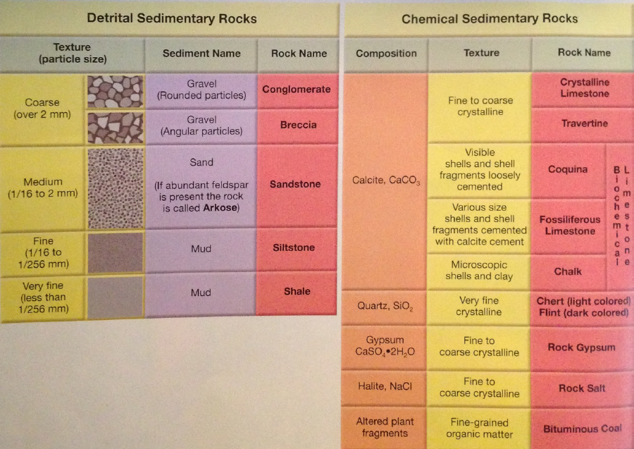
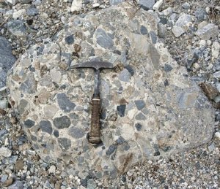
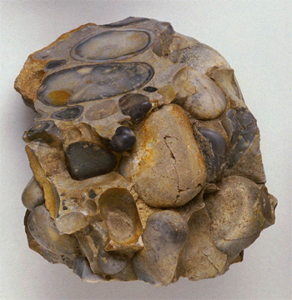
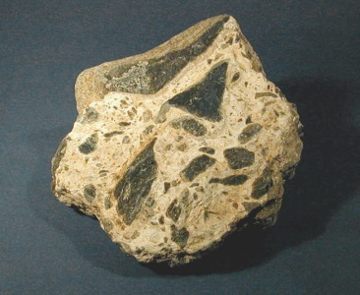
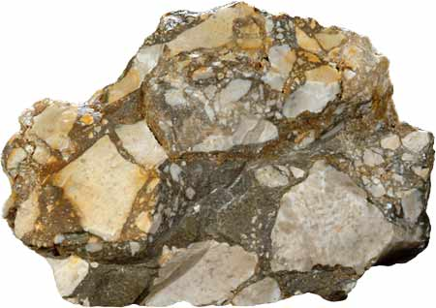
Conglomerate vs. Breccia

