Rocks
- Magma – hot, molten rock from the Earth’s interior is the _________________________________________ for all rocks.
- Three Major Types of Rock
  - ________________________________________
  - Sedimentary Rock
  - ________________________________________
Rock Cycle
- Any of the 3 major types of rock can be changed into ___________________________________. Various geological forces and processes cause the rock to change from one major type to another and back again.
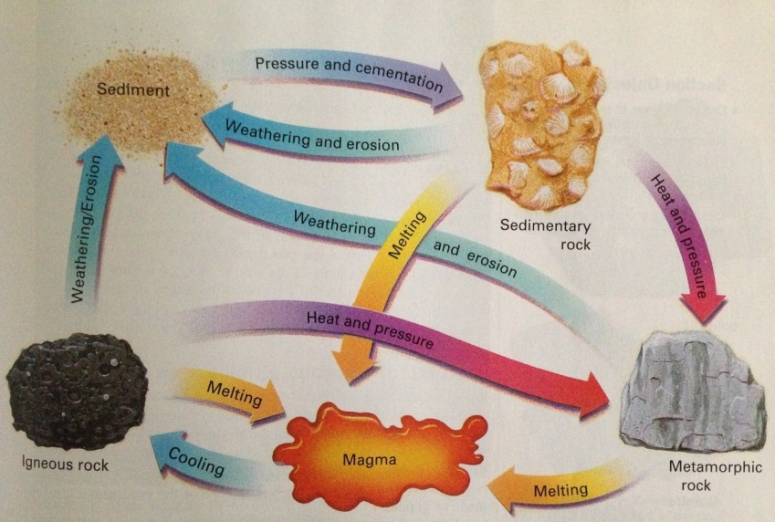
Igneous Rocks
- Formed when magma cools and _______________________________________________.
- Most ______________________________________ rock on Earth
- ________________________________ (Plutonic) – Igneous rocks that are formed below the Earth’s surface
  - Slow rate of cooling, which results in the formation of large crystals (coarse-grained)
- Extrusive (Volcanic) – Igneous rocks that are formed at the Earth’s surface.
  - Rapid cooling – results in formations of ____________________________________ (fine-grained)

Classifying Igneous Rocks
- Igneous rocks are classified by texture and _______________________________________ composition.
  - ___________________________________ – size, shape, and arrangement of interlocking crystals
    - Fine-grained
    - Coarse-grained
    - ___________________________________
    - Glassy
Fine-grained Texture
- Extrusive Igneous Rock
  - crystals to small to be seen by the __________________________________________ eye.
- Vesicles are common in fine-grained igneous rocks.
  - Vesicles are voids that are left by ______________________________________ that are formed as the lava is solidified.
Coarse-grained Texture
- Intrusive Igneous Rocks
  - Formed below the Earth’s surface
  - Slow cooling allowing for ______________________________ crystals to form
  - Crystals
    - roughly ____________________________ in size
    - Can be seen by the unaided eye
Porphyritic Texture
- When magma that already contains some large crystals suddenly erupts at the surface, the remaining molten portion of the lava would ______________________________________________.
  - Resulting Rock
    - Large crystals _______________________________________ in a matrix of smaller crystals

Glassy Texture
- Formed during _____________________________________ eruptions, molten rock is ejected into the atmosphere, where it is cooled very quickly.
Composition of Igneous Rocks
- Igneous rocks are mainly composed of _____________________________________________ minerals.
- __________________________ Silicates – are rich in iron and/or magnesium and are relatively low in silica.
  - Olivine, pyroxene, amphibole, and biotite mica are common dark silicates.
- Light Silicates – contain greater amounts of potassium, sodium, and ________________________________
  - Quartz, muscovite mica, and feldspars (most abundant mineral group)
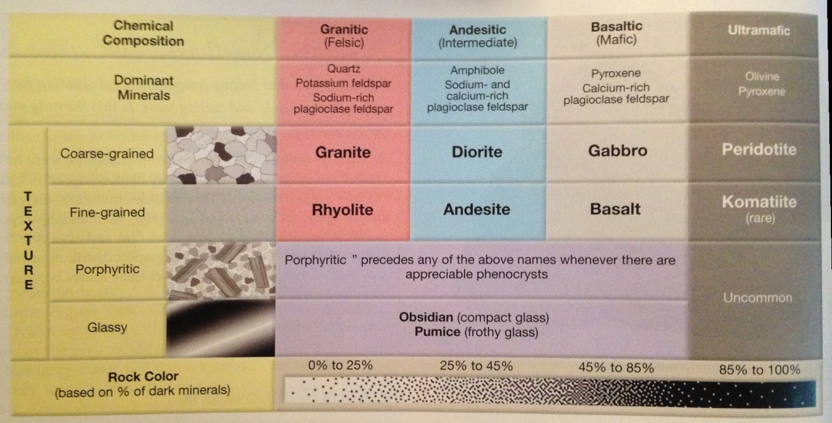
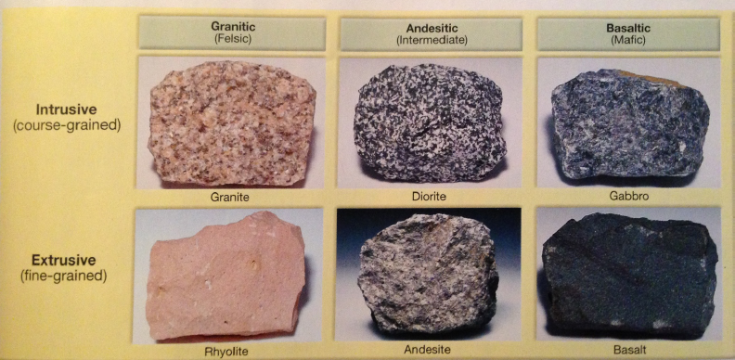
Bowen’s Reaction Series
