PROBLEM OF THE WEEK –
OCTOBER 31 - NOVEMBER 4

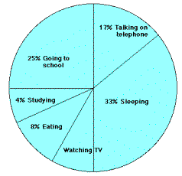
The graph at the right represents the typical day of a teenager. Answer these questions:
  - What percent of the day is spent watching TV?
  - How many hours are spent sleeping?
  - What activity takes up the least amount of time?
  - What activity takes up a quarter of the day?
  - What two activities take up 50% of the day?
  - What two activities take up 25% of the day?

Write answers on the bottom of this page:

