**PROBLEM OF THE WEEK – WEEK 6**

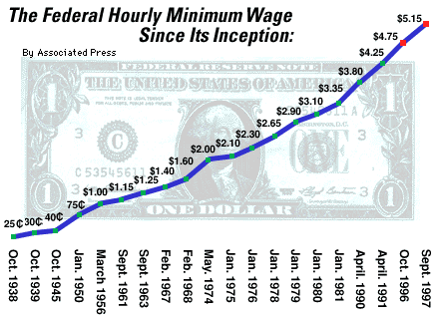

1. What was the minimum wage in January, 1978?

2. When did the minimum wage reach $3.35?

3. Between what time periods was the largest increase in minimum wage?

4. Based on your observations of the graph, make a prediction about what the wage might be in the year 2000.

5. What about the scales used on the graph might make the data appear differently than how it really is?

Directions: Make a line graph for each set of data below. Label both the x (horizontal) and y (vertical) axis properly. Give each graph a title.

|  |  |  |  |  |  |  |  |  |  |  |  |  |  |  |  |  |  |  |  |  |  |  |  |  |  |  |  |  |  |  |  |  |  |  |  |  |  |  |  |  |  |  |  |  |  |  |  |  |  |  |  |  |  |  |  |  |  |  |  |  |  |  |  |  |  |  |  |  |  |  |  |  |  |  |  |  |  |  |  |  |  |  |  |  |  |  |  |  |  |  |  |  |  |  |  |  |  |  |  |  |  |  |  |  |  |  |  |  |  |  |  |  |  |  |  |  |  |  |  |  |  |  |  |  |  |  |  |  |  |  |  |  |  |  |  |  |  |  |  |  |  |  |  |  |  |  |  |  |  |  |  |  |  |  |  |  |  |  |  |  |  |  |  |  |  |  |  |  |  |  |  |  |  |
| --- | --- | --- | --- | --- | --- | --- | --- | --- | --- | --- | --- | --- | --- | --- | --- | --- | --- | --- | --- | --- | --- | --- | --- | --- | --- | --- | --- | --- | --- | --- | --- | --- | --- | --- | --- | --- | --- | --- | --- | --- | --- | --- | --- | --- | --- | --- | --- | --- | --- | --- | --- | --- | --- | --- | --- | --- | --- | --- | --- | --- | --- | --- | --- | --- | --- | --- | --- | --- | --- | --- | --- | --- | --- | --- | --- | --- | --- | --- | --- | --- | --- | --- | --- | --- | --- | --- | --- | --- | --- | --- | --- | --- | --- | --- | --- | --- | --- | --- | --- | --- | --- | --- | --- | --- | --- | --- | --- | --- | --- | --- | --- | --- | --- | --- | --- | --- | --- | --- | --- | --- | --- | --- | --- | --- | --- | --- | --- | --- | --- | --- | --- | --- | --- | --- | --- | --- | --- | --- | --- | --- | --- | --- | --- | --- | --- | --- | --- | --- | --- | --- | --- | --- | --- | --- | --- | --- | --- | --- | --- | --- | --- | --- | --- | --- | --- | --- | --- | --- | --- | --- | --- | --- | --- |
| |  |  | | --- | --- | | **Rainfall (mL)** | **Time (hr)** | | **5** | **1** | | **2** | **2** | | **12** | **3** | | **7** | **4** | | **4** | **5** | | **8** | **6** | | **2** | **7** | | **1** | **8** | | **6** | **9** | | **3** | **10** | | |  |  |  |  |  |  |  |  |  |  | | --- | --- | --- | --- | --- | --- | --- | --- | --- | --- | |  |  |  |  |  |  |  |  |  |  | |  |  |  |  |  |  |  |  |  |  | |  |  |  |  |  |  |  |  |  |  | |  |  |  |  |  |  |  |  |  |  | |  |  |  |  |  |  |  |  |  |  | |  |  |  |  |  |  |  |  |  |  | |  |  |  |  |  |  |  |  |  |  | |  |  |  |  |  |  |  |  |  |  | |  |  |  |  |  |  |  |  |  |  | |  |  |  |  |  |  |  |  |  |  | |  |  |  |  |  |  |  |  |  |  | |  |  |  |  |  |  |  |  |  |  | |  |  |  |  |  |  |  |  |  |  | |  |  |  |  |  |  |  |  |  |  | |  |  |  |  |  |  |  |  |  |  | |