Activity: Human Homologous Chromosomes
Name: ___________________________________ Per. _____ Date: _________________

Background: A human Somatic (body) cell has 23 pairs of chromosomes in its nucleus. Each pair of Autosome chromosomes is Homologous meaning they have a matching size, shape and gene location. One member of each pair is from the person’s father ♂. The other member is from the mother ♀. The only pair of chromosomes that is not necessarily made of a matching homologous is the pair of sex chromosomes. A human female has two homologous X chromosomes but, a human male has an un-matching pair made up of an X chromosome and a Y chromosome.
Figure 1

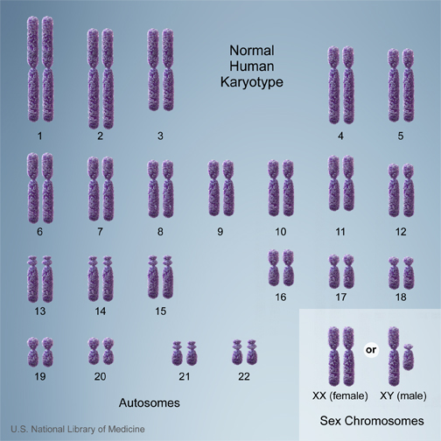
Objective: Prepare a karyotype of human chromosomes.

Materials: | paper | scissors
 | pencil | glue
Procedure:
1. Figure 1 shows 46 chromosomes from a human body cell. Note that 23rd sex chromosome pair shows examples for both male and female.

2. Use the Cut and Paste Karyotyping Activity sheet (page 2) to carefully cut out each numbered chromosome with its identifying letter or number.
- Place each numbered chromosome in the corresponding numbered box in the Chart 1 (page 3).
- Carefully glue each chromosome in place.

3. Cut out the unnumbered chromosomes located in the box on the Cut and Paste Karyotype Activity (page 2).
- Match each unnumbered chromosome to its homologous chromosome and glue next to the homologous chromosome in the proper box of Chart 1.

4. The last unmatched chromosome is the sex chromosome number 23.
- Glue the sex chromosome in box number 23.
- Answer the question as to whether the karyotype of a human male or female in the final box of Chart 1.

5. Complete the following conclusion questions below.

Conclusion:
- How many chromosomes do humans have? ____________________
- How many pairs of homologous chromosomes do humans have? ______________
- How is it you get a pair of matching chromosomes (Where does each chromosome come from)? _________________________________________________________
4. What factors did you use to match up the chromosomes? ______________________
5. When your body cells divide these chromosomes will be duplicated. What is the name of the process? __________________________________
6. When your sex cells divide the chromosomes will be reduced to half. What is the name of this process? _____________________________
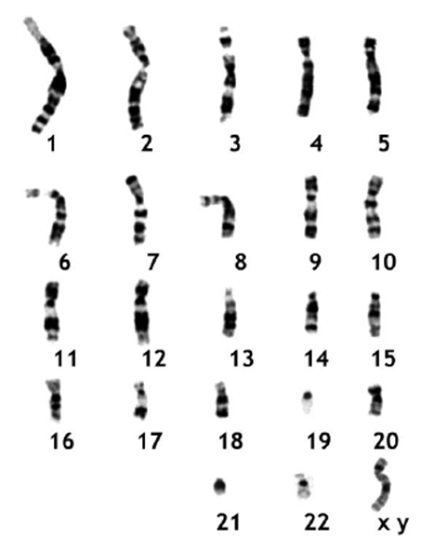
Page 2
Name: _______________________________________ Per. _____ Date: _______

Chart 1 Glue the homologous pairs on the chart
1 | 2 | 3 | 4 | 5
6 | 7 | 8 | 9 | 10
11 | 12 | 13 | 14 | 15
16 | 17 | 18 | 19 | 20
21 | 22 | 23 | Is this the karyotype of a human female or human male?  _________________________  Why? ___________________

Page 3

