Earth System Notes: Open vs. Closed System
Open System
- Open System – a system in which both _________________ and _________________ are exchanged with the surroundings.
- Example:
  - Human Body
  - Take in ___________ and air (O2)
  - Breathe out ________________
Closed System
- Closed System – a system in which_________________________, but not matter, is _____________________ with the surroundings.
- Example:
  - Watch
  - Self contained
  - All kinds of interacting parts with little or no interaction with environment
Earth is a Closed System
- Energy in the form of solar radiation passes from the Sun, through the atmosphere to the surface. The Earth in turn emits radiation back out to space across the system boundary. Hence, energy passes across the Earth's system boundary, but not mass, making it a Closed system.
Earth as a Closed System
- Earth itself is a closed system
  - _______________________is possible exception, but it is man made.
  - ___________________ is another possible exception.

Interactions of Four Spheres
- Four spheres are open systems
- Matter and _________________ are constantly exchanged between the __________________ via:
  - Chemical reactions, _________________________, radiation (light and heat), growth and decay of organisms
- Matter and energy move between spheres in order to complete certain cycles in Earth’s system
  - Cycles: Energy, water, nitrogen, _______________________________, and rock cycles
Water Cycle
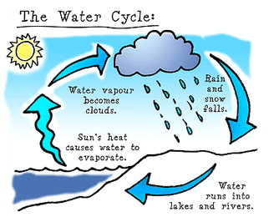
Carbon Cycle
- Like the water cycle, we also have a __________________________ where carbon is moving from sphere to sphere.
- How does carbon return to the atmosphere?
  - _________________
  - Decay
  - ________________

Nitrogen Cycle
