Unit: ____ DA: Dimensional Analysis Last Name, first Name: _________________________________________________ Date: _______ Period: ____
Objective: Students will use terminology and units they are familiar with (money and time) in order to learn the process of problem-solving using dimensional analysis so they can solve mole calculation problems in chemistry.
Topic | Molar Conversion
SC.CH.5.2 | Calculate the number of moles needed to produce a given gas, volume, mass, and/or number of moles of a product given a chemical equation
HI-Standard (in preparation for learning the following:)
- With your group, please make a dollar for each set of coins. Discuss with your group if the dimes and the nickels measure the same thing. Now, write a mathematical relationship showing this.
My mathematical relationship: | A different mathematical relationship than mine:

- Discuss in your groups if the two fractions shown on the prezi equal the same amount.
I think:  because | My group thinks:  because
Based on the whole-class discussion, is your answer different? Please revise your answer in the space below.

Definition: Conversion factors change something to a different version or form. A factor is something that brings results or a cause, while conversion is the action of changing the “version” of a thing. In math (algebra), a conversion factor is used to convert a measured quantity to a different unit of measure without changing the relative amount. To accomplish this, a ratio (fraction) is established that equals one (1). In the ratio, the conversion factor is a multiplier that, when applied to the larger unit, converts the larger unit into the smaller unit, by multiplication with the measured amount.
It’s a proportion! Check it out…

- Write a conversion factor for…
Dimes and Quarters in 1 dollar | Seconds in 1 minute | Days in 1 year | Years in 1 decade | Decades in 1 century
- Criss-Cross Applesauce! (need your colored pencils) Follow along with the demonstration.
=
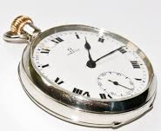
- Let’s Practice together…How many seconds are there in 2.5 hours?
Conversions:
60 seconds = 1 minute 365 days = 1 year
1 hour = 60 minutes 1 day = 24 hours

- Now, it’s your turn…How many seconds are there in 1 day?

- How many seconds are there in 1 decade?

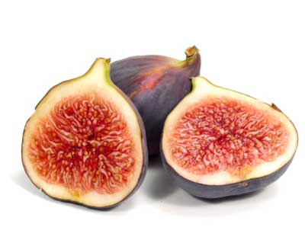
Bet you didn’t know…A fig "fruit" is derived from a specially adapted type of inflorescence (an arrangement of multiple flowers). In this case, it is an involuted, nearly closed receptacle with many small flowers arranged on the inner surface. Thus the actual flowers of the fig are unseen unless the fig is cut open. The flowers are pollinated by very small wasps that crawl through the opening in search of a suitable place to lay eggs. Without this pollinator service fig trees could not reproduce by seed. In turn, the flowers provide a safe haven and nourishment for the next generation of wasps. This accounts for the frequent presence of wasp larvae in the fruit, and has led to a coevolutionary relationship.
Source: Wikipedia “ficus”
- That’s a whole lot of numbers…How do you know what place to round to?

